Jackson County Fire District 4

Monthly Report: August 2023

Total Number of Incidents for August 2023 86

Average Response time
Dispatched and cancelled enroute calls have been excluded

 | Average Response Time | # of Calls
City limits | 5:39 | 45
Non City/Rural | 13:40 | 25

Monthly Call Volume

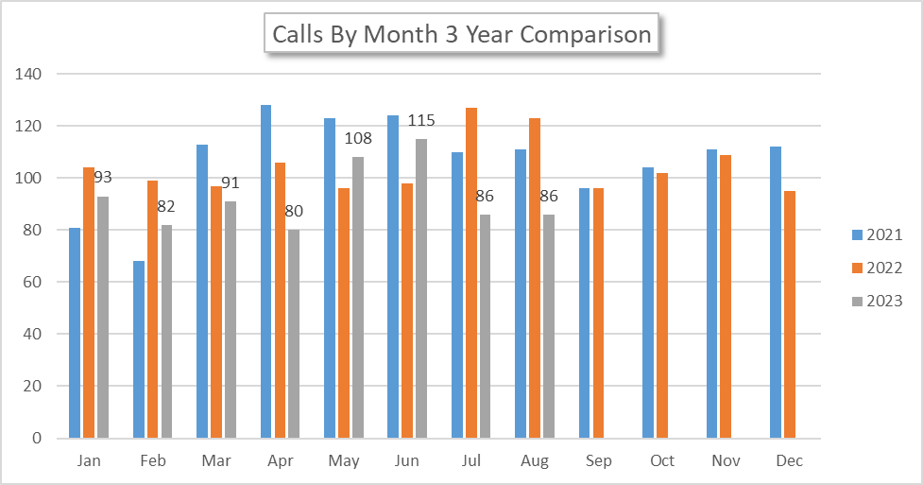
Breakdown by Major Incident Type

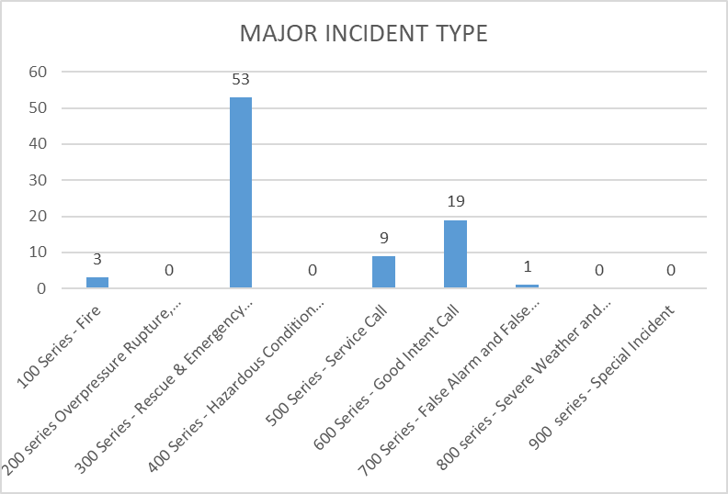

MAJOR INCIDENT TYPE | # INCIDENTS | % of TOTAL
100 Series - Fire | 3 | 3.53%
200 series Overpressure Rupture, Explosion, Overheat No Fire | 0 | 0.00%
300 Series - Rescue & Emergency Medical Service | 53 | 62.35%
400 Series - Hazardous Condition (No Fire) | 0 | 0.00%
500 Series - Service Call | 9 | 10.59%
600 Series - Good Intent Call | 19 | 22.35%
700 Series - False Alarm and False Call | 1 | 1.18%
800 series - Severe Weather and Natural Disaster | 0 | 0.00%
900 series - Special Incident | 0 | 0.00%
TOTAL | 85 | 100%

Call History

